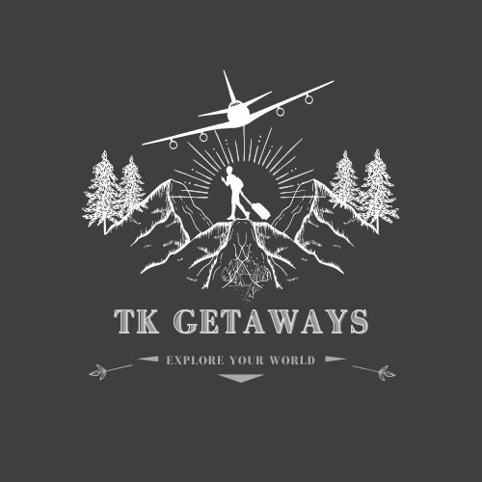

**TK Getaways Special Offers**

## **Universal Orlando Vacation Package**

**Vacation Package Includes:**

* **1-3 Night Hotel Accommodations with benefits of staying at Select Universal Orlando Resort Hotels**
  + **Free** Universal Express Unlimited Ride Access (Select Hotels):** Guests staying at Loews Portofino Bay Hotel can skip the regular lines at Universal Studios and Islands of Adventure. (Valid theme park admission required; select attractions.)
  + **Early Park Admission**† to The Wizarding World of Harry Potter™ and Universal Volcano Bay up to one hour before the park opens (valid theme park admission required. Select attractions.)
  + **Complimentary transportation to the theme parks and Universal CityWalk**
  + **And More**
* **2-Park or 3-Park-to-Park Tickets for 1-3 Days that enables guests to visit multiple parks on the same day with the following options:**
  + 2-Park: Universal Studios Florida and Universal Islands of Adventure
  + 3-Park: Universal Studios Florida, Universal Islands of Adventure, and Universal Volcano Bay
* **One way transportation service** between Port Canaveral and one of the Universal Orlando Resort Hotels



Search:



[Mystical Peru](https://www.mayflowercruisesandtours.com/tour/mystical-peru/)

##### **2 FOR 1 AIRFARE**

9 DAYS • 16 MEALS

From $3429

[](https://www.mayflowercruisesandtours.com/tour/mystical-peru/)

Flavors of India

##### **2 FOR 1 AIRFARE**

12 DAYS • 22 MEALS

From $3099

[](https://www.mayflowercruisesandtours.com/tour/flavors-of-india/)

[Iceland – Land of Fire and Ice](https://www.mayflowercruisesandtours.com/tour/iceland-land-of-fire-and-ice/)

##### **FREE ROUND TRIP AIRFARE**

7 DAYS • 7 MEALS

From $3199



[London and Paris Discovery](https://www.mayflowercruisesandtours.com/tour/london-and-paris-discovery/)

##### **FREE ROUND TRIP AIRFARE**

9 DAYS • 9 MEALS

From $3999

| **TLN Cruise Sale Dates for 2025** |
| --- |
|  |
| • **February 11-26**  • May 9-24  • September 13-28  • November 15-30 |

**When you book during these dates, you will receive:**

• Reduced deposits, as low as $50 per guest‡• Digital coupon book with more than $900 in onboard savings† — includes offers for specialty dining, The Shops of Princess®, Effy® Jewelry, wine tasting, shore excursions, Lotus Spa® and more